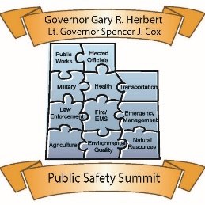

Registration is Open!

The 11th Annual Governor’s Public Safety Summit
Standing Together for
Public Safety and Stronger Communities
May 22-23, 2018 · St. George, Utah
The Governor’s Public Safety Summit Registration is open! Click here to register online. The early bird rate of $250 will expire Feb. 28. So register today!
You will need to book your own hotel stay. A block of rooms has been reserved at the state rate of $85.00 per night. Be sure to tell them you are with the Governor’s Public Safety Summit to obtain the state rate. Here are the hotels that are participating in our room block:
- Best Western Plus Abbey Inn: 1129 South Bluff Street, St. George (435)652-1234 Abbey Inn
- Courtyard Marriott: 185 S 1470 E, St George, UT 84790 (435)986-0555 St. George Marriott
- TownePlace Suites: 251 S 1470 E, St George, UT 84790 (435)986-9955 TownePlace Suites St. George
- Fairfield Inn by Marriott: 1660 South Convention Center Drive, St. George (435)673-6066 Fairfield Inn
- Hyatt Place: 1819 South 120 East, St George, UT 84790 (435) 656-8686 Hyatt Place

We have a great agenda prepared for you. Our keynote speakers will present on how collaboration and partnerships have helped them in their duties and responses. We will discuss Operation Rio Grande and how true partnerships have resulted in reduced crime and a cleaned up area in downtown SLC. We have invited law enforcement from Las Vegas to discuss the shooting incident that occurred in October and how they stood together to become stronger and more united. Also we are inviting a speaker from the California mudslides to talk about their response and recovery efforts during their devastating fires and debris flow. We have many more great speakers lined up, we hope you will join us!
May 22-23, 2018
St. George Utah - Dixie Convention Center

