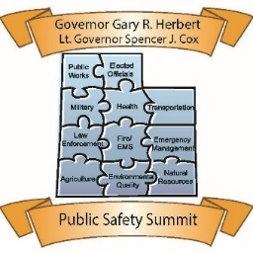
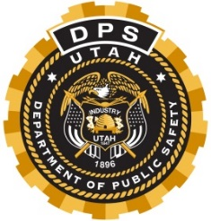
Governor’s Public Safety Summit
“Standing Together for Public Safety and Stronger Communities”
May 22-23, 2018 · St. George, Utah · Dixie Convention Center
1835 S. Convention Center Drive · 435-628-7003
____________________________________________________________________________

DAY ONE Tuesday, May 22
7:00 – 8:00 Full Breakfast – Exhibits Open
8:00 - 8:30 Welcome – DPS Commissioner Keith Squires
Posting of Flag and National Anthem
Welcome - Lt. Governor Spencer J. Cox

8:30 - 10:00 Keynote Address
Operation Rio Grande Keith D. Squires – Commissioner
Utah Department of Public Safety
10:00 - 10:30 Break (food) Exhibit Hall

10:30 – 12:00 Keynote Address
When Disaster Strikes Twice Sheriff Bill Brown – Santa Barbara County

12:00 - 1:00 Lunch Exhibit Hall

1:00 - 2:00 Breakout Session #1
1. | Sexual Assault Kit Initiative (SAKI) Improving Response to Sexual Assault | Ballroom A
2. | Youth Suicide Prevention | Ballroom B
3. | Domestic Terrorism | Ballroom D/F
4. | Box Elder County Fires / Hazmat | Entrada A
5. | Media and First Responders Working Together | Entrada B/C
6. | Unified Police’s Mental Health Unit | Sunbrook A/B
7. | Environmental Health in Emergencies | Sunbrook C

2:00 - 2:15 Break Exhibit Hall

2:15 – 3:15 Breakout Session #2
1. | Civil Support Team Capabilities – Helping You When You Need it | Ballroom A
2. | Refugee Program #1 Breakout | Ballroom B
3. | An Introduction to Human Trafficking in Utah | Ballroom D/F
4. | Public Health Role in Emergency Management – Just What the Doctor Ordered | Entrada A
5. | Transportation Accidents Involving Radioactive Material | Entrada B/C
6. | Disasterville – A Training, Marketing, Skills Refresher, and Education Tool | Sunbrook A/B
7. | Brigham City Prepares and Mitigates Against Future Flooding | Sunbrook C

3:15 – 3: 45 Break (food) Exhibit Hall

3:45 – 4:45 Breakout Session #3
1. | DPS Aero Bureau - Helicopter Hoist Capabilities | Ballroom A
2. | Opioid Epidemic | Ballroom C/E
3. | SIAC | Ballroom D/F
4. | Medical Triage from the Las Vegas Shooting Incident | Entrada A
5. | Utah’s Response to the California Wildfires | Entrada B/C
6. | Utah Victim Information and Notification – Helping Keep Communities Safe and Informed | Sunbrook A/B
7. | Debris Management, FEMA Rules and Guidelines | Sunbrook C

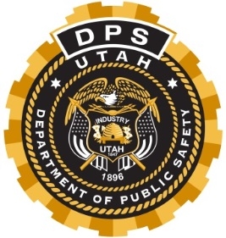
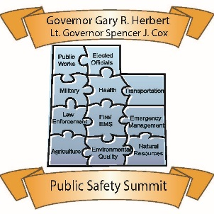
Governor’s Public Safety Summit
“Standing Together for Public Safety and Stronger Communities”
Eleventh Annual Governor’s Public Safety Summit

DAY TWO Wednesday, May 23
7:00 - 1:30 Registration open Lobby
7:00 - 1:30 Exhibits open Exhibit Hall
7:00 - 8:00 Full Breakfast Exhibit Hall

8:00 Welcome – Lt. Governor Spencer J. Cox

8:20 - 10:00 Keynote Speaker
Las Vegas Shooting - Deputy Chief Shawn Anderson, Las Vegas Metro Police Dept.

10:00-10:30 Break (food) Exhibit Hall

10:30-11:30 Breakout Session #4
1. | Criminal Investigative Tools and Services for Local Agencies | Ballroom A
2. | Role of Victim Services During a Mass Casualty Incident #1 | Ballroom C/E
3. | NCTC – JCAT “Understanding the First Responder Role in Counterterrorism” LE only | Ballroom D/F
4. | Invite Only – Governor’s Lunch | Entrada A
5. | How To Survive a Nuclear Attack | Entrada B/C
6. | Breakout Repeat Presentation | Sunbrook A/B
7. | Houston Mass Care Lessons Learned | Sunbrook C

11:30 - 12:30 Lunch Exhibit Hall

12:30 – 1:30 Breakout Session #5
1. | Law Enforcement Use of the National Integrated Ballistic Information Network (NIBIN) | Ballroom A
2. | Role of Victim Services During a Mass Casualty Incident #2 | Ballroom C/E
3. | Privacy Is Not So Private: Identifying Targets Through Open Source Techniques | Ballroom D/F
4. | Invite Only – Governor’s Lunch | Entrada A
5. | Utah 24/7 Pilot Program | Entrada A
6. | DPS Communications: Case Study, Best Practices | Entrada B/C
7. | Disaster Response to Puerto Rico – Formerly Known as America’s Garden Spot | Sunbrook A/B

1:40-2:30 Closing Remarks: Governor Gary R. Herbert

Prize Drawing – Please turn in your Conference Evaluations
Food break “to go”
Adjourn – Thank you for coming, be safe going home!

