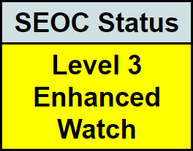
This information is from the previous 24 hours

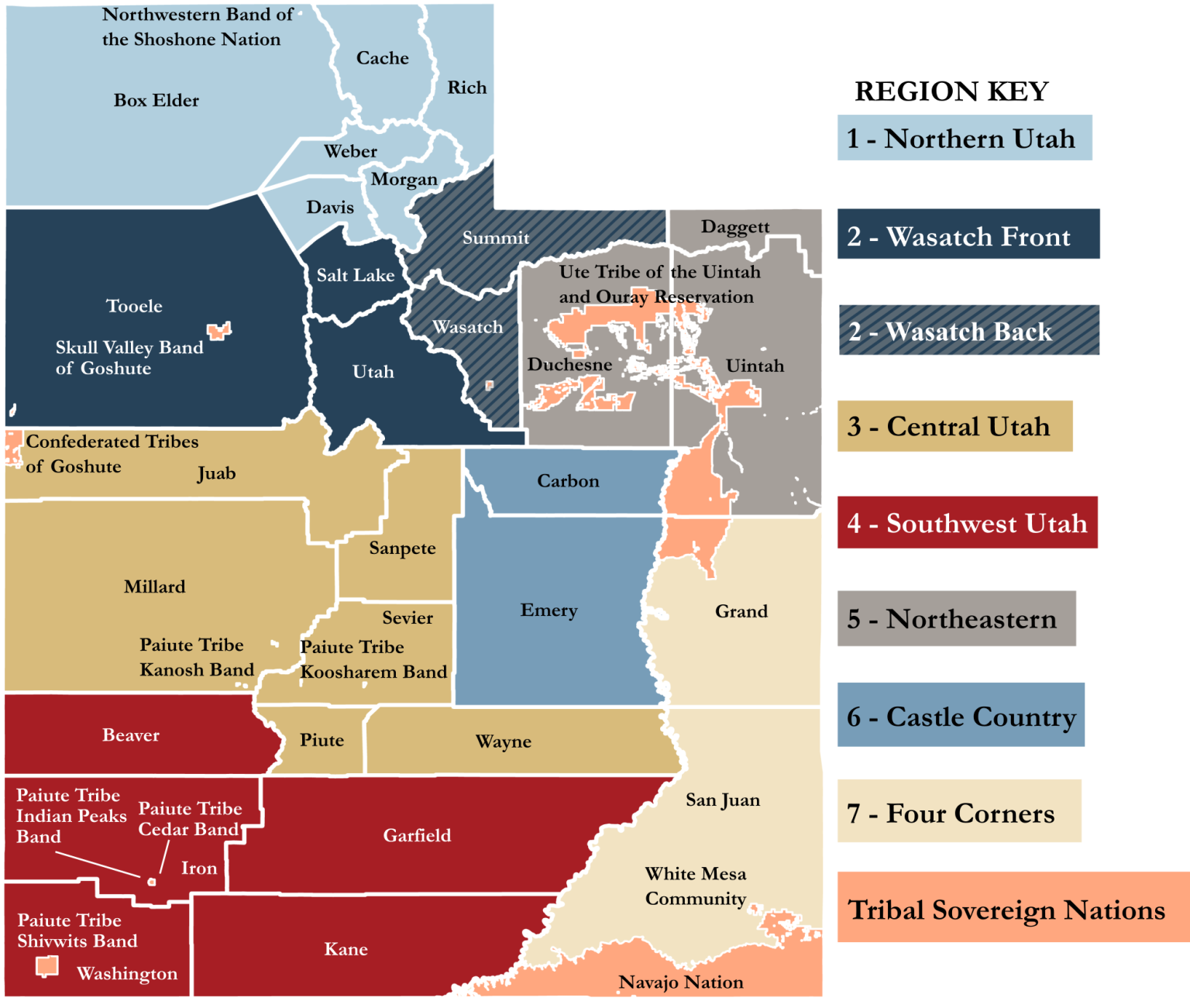
April 20, 2023 as of 07:00

State Lifeline Status
CLICK HERE TO SEE A CURRENT MAP FOR INCIDENTS STATEWIDE

Significant State Activity
Active The State of Utah has declared a State of Emergency due to flooding, expiring 5/18/23.
Active Active Areas of Flooding Concern - (Region 1) Weber River, Ogden River, Hyrum Dam, (Region 2) Emigration Creek near Salt Lake City’s East Bench, Spanish Fork Canyon, between 1500 E. and 1700 E. in Salt Lake City, the Town of Alta, Big Cottonwood Creek, Little Cottonwood Creek, and Parleys Canyon burn scar. (Region 4) Baker Dam, (Region 6) Bear Fire burn scar, Trail Mountain burn scar, Scofield Reservoir, Clear Creek, (Region 7) Pack Creek, Mill Creek, Spanish Valley, Bluff, and the Dolores River.*
*Areas area identified through various local and State resources and reflect a range of timeframes for concern

Other Immediate Concerns
- Active Current flood risk is spring runoff, increasing streamflows, and snowmelt.

Current State (SERT) Actions
- New UDOT has increased their emergency operations profile to Monitoring and has stood up their emergency coordination center (ECC). [UDOT]
- Active 7 stream monitoring camera locations have been identified in coordination with USGS and will be deployed within the next week. An additional 8 cameras will be reviewed this week for deployment. [WebEOC]
- Active Activated Emergency Support Functions: ESF #1, ESF #5, ESF #14, ESF #15, Logistics, VDCT, and Finance.

Current Operational Requests
- Update 9 active requests are in progress regarding State sandbag resources, management of State volunteers, additional SEOC staff, other flooding response resources, and for information regarding ability to assist with flooding from USACE. 1 active request is pending additional information for flooding response resources. [WebEOC]

Region 1
Davis County
- New Kaysville City has declared a local emergency due to significant runoff damage in the Orchard Ridge Division, expiring on 5/19/23.

Region 2
Summit County
- Update Oakley City flooding is remaining stable. [LNO Correspondence]
Salt Lake County
- Update Emigration Canyon is holding steady. [LNO Correspondence]
- Active Millcreek declared a local emergency related to flooding, expiring on 5/13/23.
- Active Emigration Canyon declared a local emergency related to flooding, expiring on 5/12/23.
- Active Salt Lake County declared a local emergency related to flooding, expiring on 5/13/23.
- Active Salt Lake City declared a local emergency relating to flooding, expiring on 5/12/23.

Region 3
Juab County
- Active Juab County declared a local emergency related to flooding, expiring on 5/17/23.
Millard County
- Update Millard County has extended their declaration for upcoming flooding to 8/31/23.

Region 4
Washington County
- New Currently monitoring Baker Dam. [LNO Correspondence]

Region 5
- No significant updates to report at this time.

Region 6/7
- No significant updates to report at this time.

Tribal Nations
- No significant updates to report at this time.
Impact and activity information is provided by Local Emergency Management partners, the State Emergency Response Team (SERT), and private and non-profit partners through various coordinating communication channels. This is a developing situation, and information may quickly become outdated. Additional situation reports may be made as verified information becomes available.

WEATHER
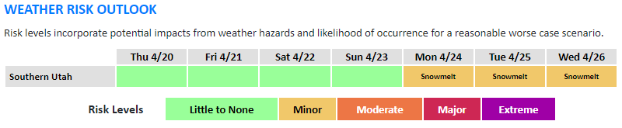
This forecast is accurate as of 4/20/23 at 0644 For a more detailed forecast, click here.
- Cooler temperatures through the end of the week will lead to decreased snowmelt.  - Update Flood Advisory in Grand County until the evening of 4/21. | - Warming temperatures will bring another period of increased snowmelt, especially across southern Utah, for the first half of next week.

SNOW WATER EQUIVALENT (SWE) IN UTAH
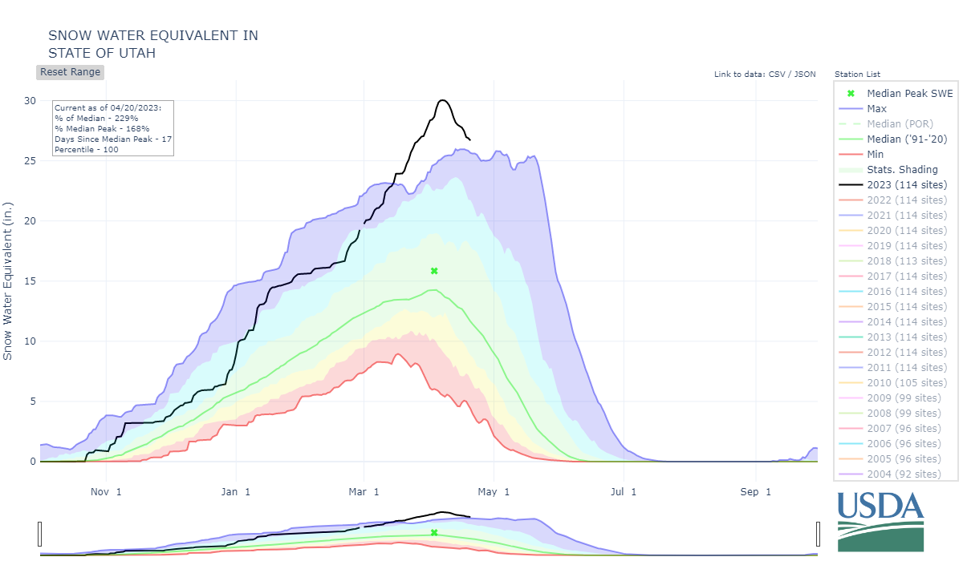

Useful Links for Flooding Awareness:
View and Download Flood Maps | NWS SLC Twitter | Reservoir Levels | Snow Water Equivalent | SNOTEL | Streamflow Gauges | Avalanche Risk | Drought Monitor | Water Dashboard | River Levels | NOAA Spring Flood Outlook
Utah Division of Emergency Management
dem.utah.gov
For questions or comments regarding this report, call 801-538-3400 or email esf05planning@utah.gov.

Acronyms
ESF - Emergency Support Function - ESF Purposes | DEM - (Utah) Division of Emergency Management
ESF #1 - Transportation | DPS - (Utah) Department of Public Safety
ESF #2 - Communications | E - East
ESF #3 - Public Works and Engineering | ECC - Emergency Coordination Center
ESF #4 - Firefighting | LNO - (State to Local) Liaison
ESF #5 - Planning | NOAA - National Oceanic and Atmospheric Administration
ESF #6 - Mass Care | NWS - National Weather Service
ESF # 7 - Resource Support | SEOC - State Emergency Operations Center
ESF #8 - Health and Medical | SERT - State Emergency Response Team
ESF #9 - Search and Rescue | SNOTEL - SNOpack TELemetry
ESF #10 - Hazardous Materials | SWE - Snow Water Equivalent
ESF #11 - Agriculture, Food, Cultural Resources, and Pets | TLP - Traffic Light Protocol
ESF #12 - Energy | UDOT - Utah Department of Transportation
ESF #13 - Law Enforcement | USACE - United States Army Corps of Engineers
ESF #14 - Disaster Recovery | USGS - United States Geological Survey
ESF #15 - Public Information | UTA - Utah Transit Authority
ESF #16 - Military Support | VDCT - Volunteer and Donations Coordination Team

